[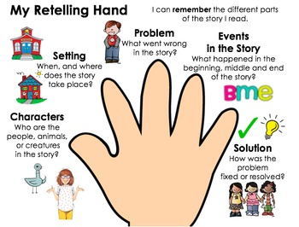](https://www.google.com/url?sa=i&rct=j&q=&esrc=s&source=images&cd=&ved=2ahUKEwjj1JWlz-fcAhUp74MKHVHOAJwQjRx6BAgBEAU&url=https://www.teacherspayteachers.com/Product/Five-Finger-Retell-Graphic-Organizer-2001694&psig=AOvVaw1-itNEzL9deViehxpBr579&ust=1534166922287608)